27th Legislative District

District Legislators
Senator Debbie Regala  Democrat | Representative Dennis Flannigan  Position 1, Democrat | Representative Jeannie Darneille  Position 2, Democrat

District Map
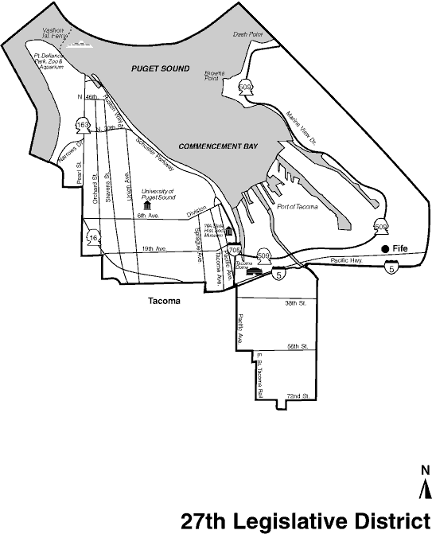

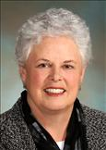 | Senator Debbie Regala  Majority Whip
 | (D) 27th LEGISLATIVE DISTRICT
Olympia Office:
233 John A. Cherberg Building
PO Box 40427
Olympia, WA 98504-0427
(360) 786-7652
Fax: (360) 786-1999
E-mail

Senator Regala's Homepage  Biography | Committees:  Human Services & Corrections  (Vice Chair)  Rules  Water Energy & Telecommunications  Ways & Means  Print Quality Photo | Bill Sponsorship

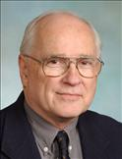 | Rep. Dennis Flannigan
 | (D) 27th LEGISLATIVE DISTRICT
 | Olympia Office:  335 John L. O'Brien Building  PO Box 40600  Olympia, WA 98504-0600  (360) 786-7930  E-mail | District Office:  738 Broadway  Suite 200  Tacoma, WA 98402  (253) 593-2345

Rep. Flannigan's Homepage  Biography  Press Room | Committees:  Transportation  (Vice Chair)  Capital Budget  Judiciary  Print Quality Photo | Voting Record:  2008  2007 Special Session  2007  2006  2005  2004  2003  Bill Sponsorship

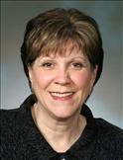 | Rep. Jeannie Darneille  Majority Caucus Vice Chair
 | (D) 27th LEGISLATIVE DISTRICT
Olympia Office:
436B Legislative Building
PO Box 40600
Olympia, WA 98504-0600
(360) 786-7974
E-mail

Rep. Darneille's Homepage  Biography  Press Room | Committees:  Appropriations Subcommittee on Health & Human Services  (Vice Chair)  Appropriations  Community & Economic Development & Trade  Human Services  Print Quality Photo | Voting Record:  2008  2007 Special Session  2007  2006  2005  2004  2003  2002  2001  Bill Sponsorship

28th Legislative District

District Legislators
Senator Mike Carrell  Republican | Representative Troy Kelley  Position 1, Democrat | Representative Tami Green  Position 2, Democrat

District Map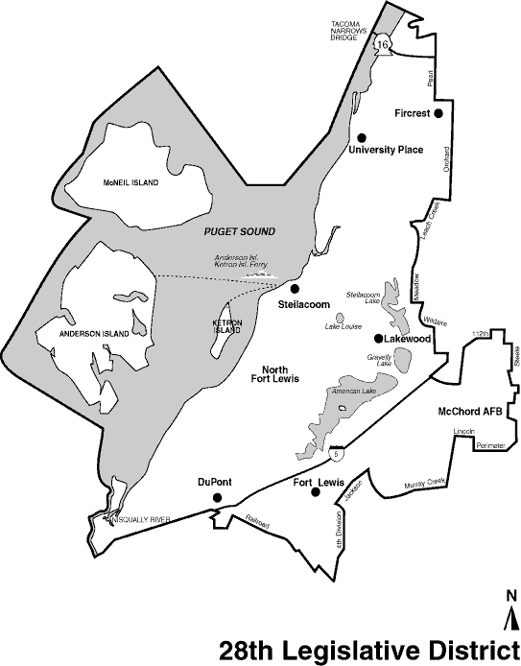

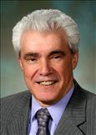 | Senator Mike Carrell  Republican Deputy Floor Leader
 | (R) 28th LEGISLATIVE DISTRICT
Olympia Office:
109A Irv Newhouse Building
PO Box 40428
Olympia, WA 98504-0428
(360) 786-7654
Fax: (360) 786-7819
E-mail

Senator Carrell's Homepage | Committees:  Health & Long-Term Care  Human Services & Corrections  Judiciary  Ways & Means  Print Quality Photo | Bill Sponsorship

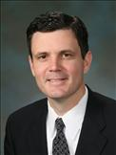 | Rep. Troy Kelley
 | (D) 28th LEGISLATIVE DISTRICT
 | Olympia Office:  319 John L. O'Brien Building  PO Box 40600  Olympia, WA 98504-0600  (360) 786-7890  E-mail | District Office:  7406 27th Street W.  Suite 207  University Place, WA 98466  (253) 534-3216

Rep. Kelley's Homepage  Biography  Press Room | Committees:  Insurance Financial Services & Consumer Protection  (Vice Chair)  Capital Budget  Rules  Technology Energy & Communications  Print Quality Photo | Voting Record:  2008  2007 Special Session  2007  Bill Sponsorship

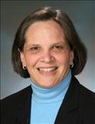 | Rep. Tami Green
 | (D) 28th LEGISLATIVE DISTRICT
 | Olympia Office:  327 John L. O'Brien Building  PO Box 40600  Olympia, WA 98504-0600  (360) 786-7958  E-mail | District Office:  7406 27th St W  Suite 207  University Place, WA 98466  (253) 534-3231

Rep. Green's Homepage  Biography  Press Room | Committees:  Appropriations  Commerce & Labor  Health Care & Wellness  Rules  Print Quality Photo | Voting Record:  2008  2007 Special Session  2007  2006  2005  Bill Sponsorship

29th Legislative District

District Legislators
Senator Rosa Franklin  Democrat | Representative Steve Conway  Position 1, Democrat | Representative Steve Kirby  Position 2, Democrat

District Map
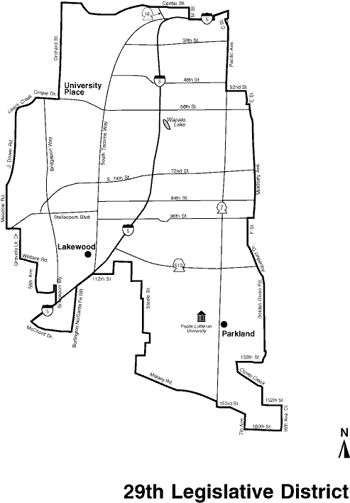

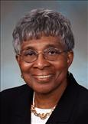 | Senator Rosa Franklin  President Pro Tempore
 | (D) 29th LEGISLATIVE DISTRICT
Olympia Office:
312 Legislative Building
PO Box 40429
Olympia, WA 98504-0429
(360) 786-7656
Fax: (360) 786-7520
E-mail

Senator Franklin's Homepage  Biography | Committees:  Health & Long-Term Care  (Vice Chair)  Rules  (Vice Chair)  Financial Institutions & Insurance  Labor Commerce Research & Development  Print Quality Photo | Bill Sponsorship  2007 Legislative Review

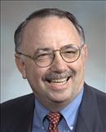 | Rep. Steve Conway
 | (D) 29th LEGISLATIVE DISTRICT
Olympia Office:
307 John L. O'Brien Building
PO Box 40600
Olympia, WA 98504-0600
(360) 786-7906
E-mail

Rep. Conway's Homepage  Biography  Press Room | Committees:  Commerce & Labor  (Chair)  Appropriations  Finance  Print Quality Photo | Voting Record:  2008  2007 Special Session  2007  2006  2005  2004  2003  2002  2001  2000  Bill Sponsorship

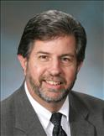 | Rep. Steve Kirby
 | (D) 29th LEGISLATIVE DISTRICT
Olympia Office:
432 John L. O'Brien Building
PO Box 40600
Olympia, WA 98504-0600
(360) 786-7996
E-mail

Rep. Kirby's Homepage  Biography  Press Room | Committees:  Insurance Financial Services & Consumer Protection  (Chair)  Judiciary  Public Safety & Emergency Preparedness  Print Quality Photo | Voting Record:  2008  2007 Special Session  2007  2006  2005  2004  2003  2002  2001  Bill Sponsorship

