**READY! Set, Read – Tacoma!**

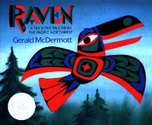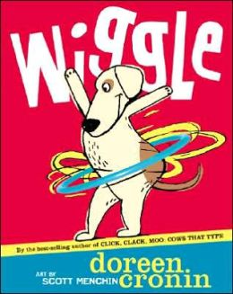

**OUR CORE BELIEF:**

We believe beginning a child’s education as early as possible will help a child to succeed in school. Our program encourages parents to read with their children. Parents and their preschoolers who attend READY! Set, Read, Tacoma! (RSR-T) will become more actively engaged in conversations around books resulting in children arriving at school ready to learn kindergarten with better social skills.

**PROGRAM GOALS:**

• Offering families and children access to 75 specially selected books and activities designed by early childhood specialists.

• Parents and children will attend RSR-T sessions where Teacher Librarians and other professional volunteers will model reading strategies and hold a child’s interest.

• Parents will receive instruction on how to engage their child /children in the high level skills and activities that are included at the end of each book.

• Our program will monitor student progress as they enter kindergarten.

**MISSION:**

To narrow, or preferably eliminate, the achievement gap in reading before a child enters kindergarten.

**GETTING INVOLVED:**

• Help us promote our program to parents and organizations, which is available at all 35 Tacoma elementary schools.

•Volunteer as and/or recruit guest readers to assist with mentoring students and parents.

• Donations of $5.00 or more will help us replace a damaged or lost book, or add books to our current collection.

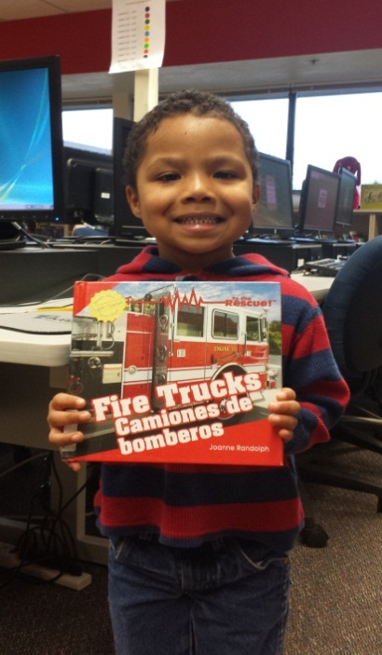



**CONTACTS:**

**Rachel Joyce** – Outreach Coordinator

Communities in Schools

READY! Set, Read-Tacoma!

[rjoyce@tacoma.k12.wa.us](mailto:rjoyce@tacoma.k12.wa.us)

253 571-1054

**Sarah Bruno**-Program Manager

Communities in Schools

READY! Set, Read-Tacoma!

[sbruno1@tacoma.k12.wa.us](mailto:sbruno1@tacoma.k12.wa.us)

253 571-1183

Visit us online: <http://tacoma.ciswa.org/services/ready-set-read-tacoma/>

