Meet and greet the horses
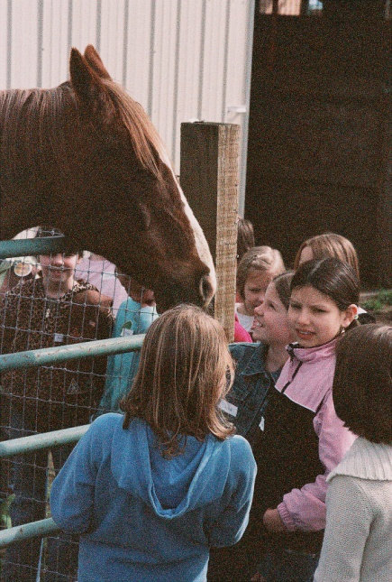
Learn how to safely walk around a horse
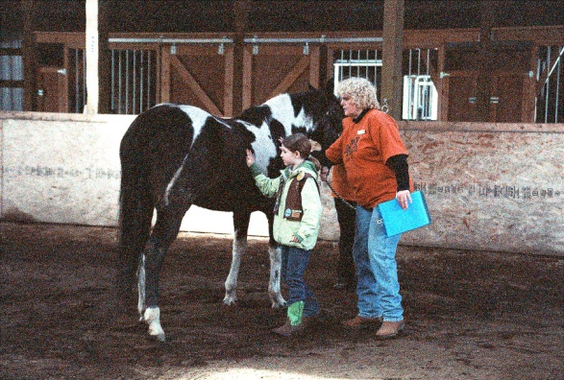

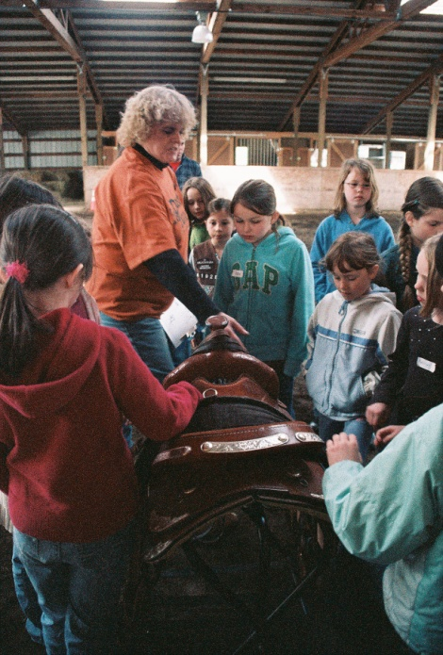
Handle English and Western tack

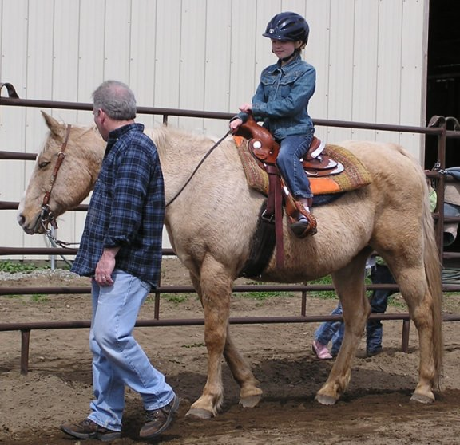

Learn how to groom a horse
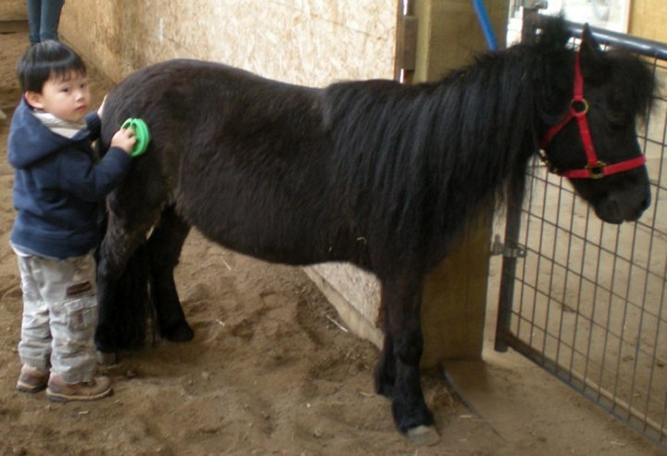

Ride in our pony cart
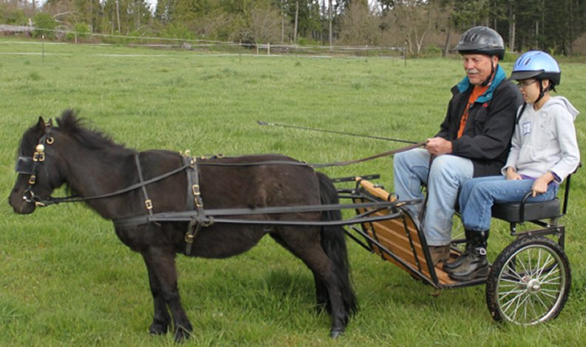

Riding

Learn the responsibility of
horse ownership
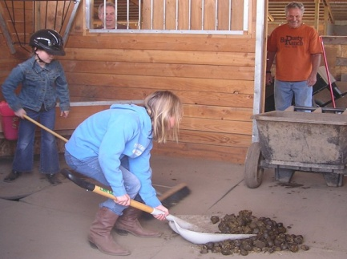

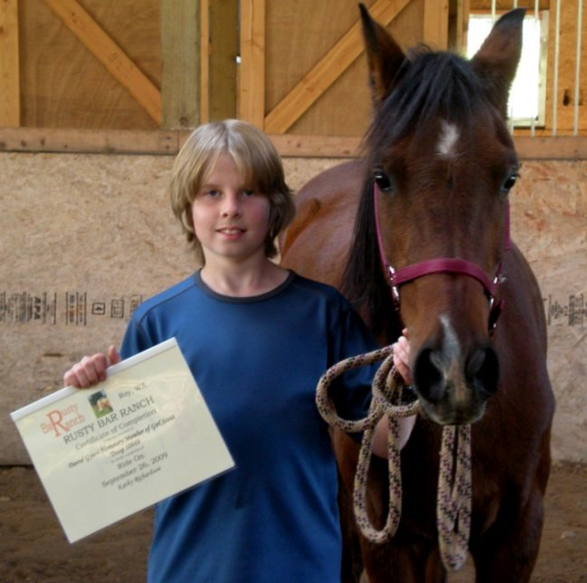

All participants receive a Horsemanship Patch,
Certificate of Participation,
and packet of information
outlining the day

Helmets are provided
Cameras are welcome
Cost for Participants: $35.00
Cost for adults: FREE
25% deposit required to reserve date
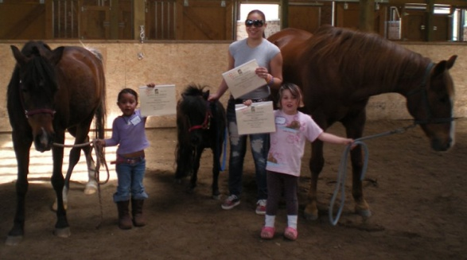
Fully enclosed indoor covered arena
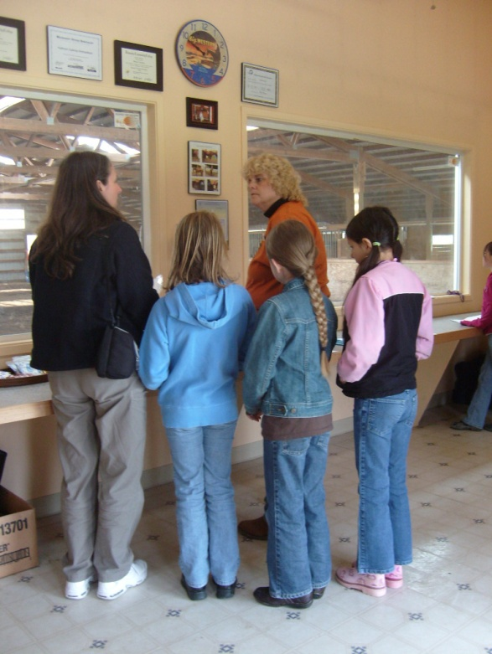
Heated viewing/multipurpose room

Presents
Life on A
Horse Ranch
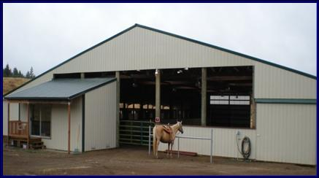

253-843-2455
www.rustybarranch.com

