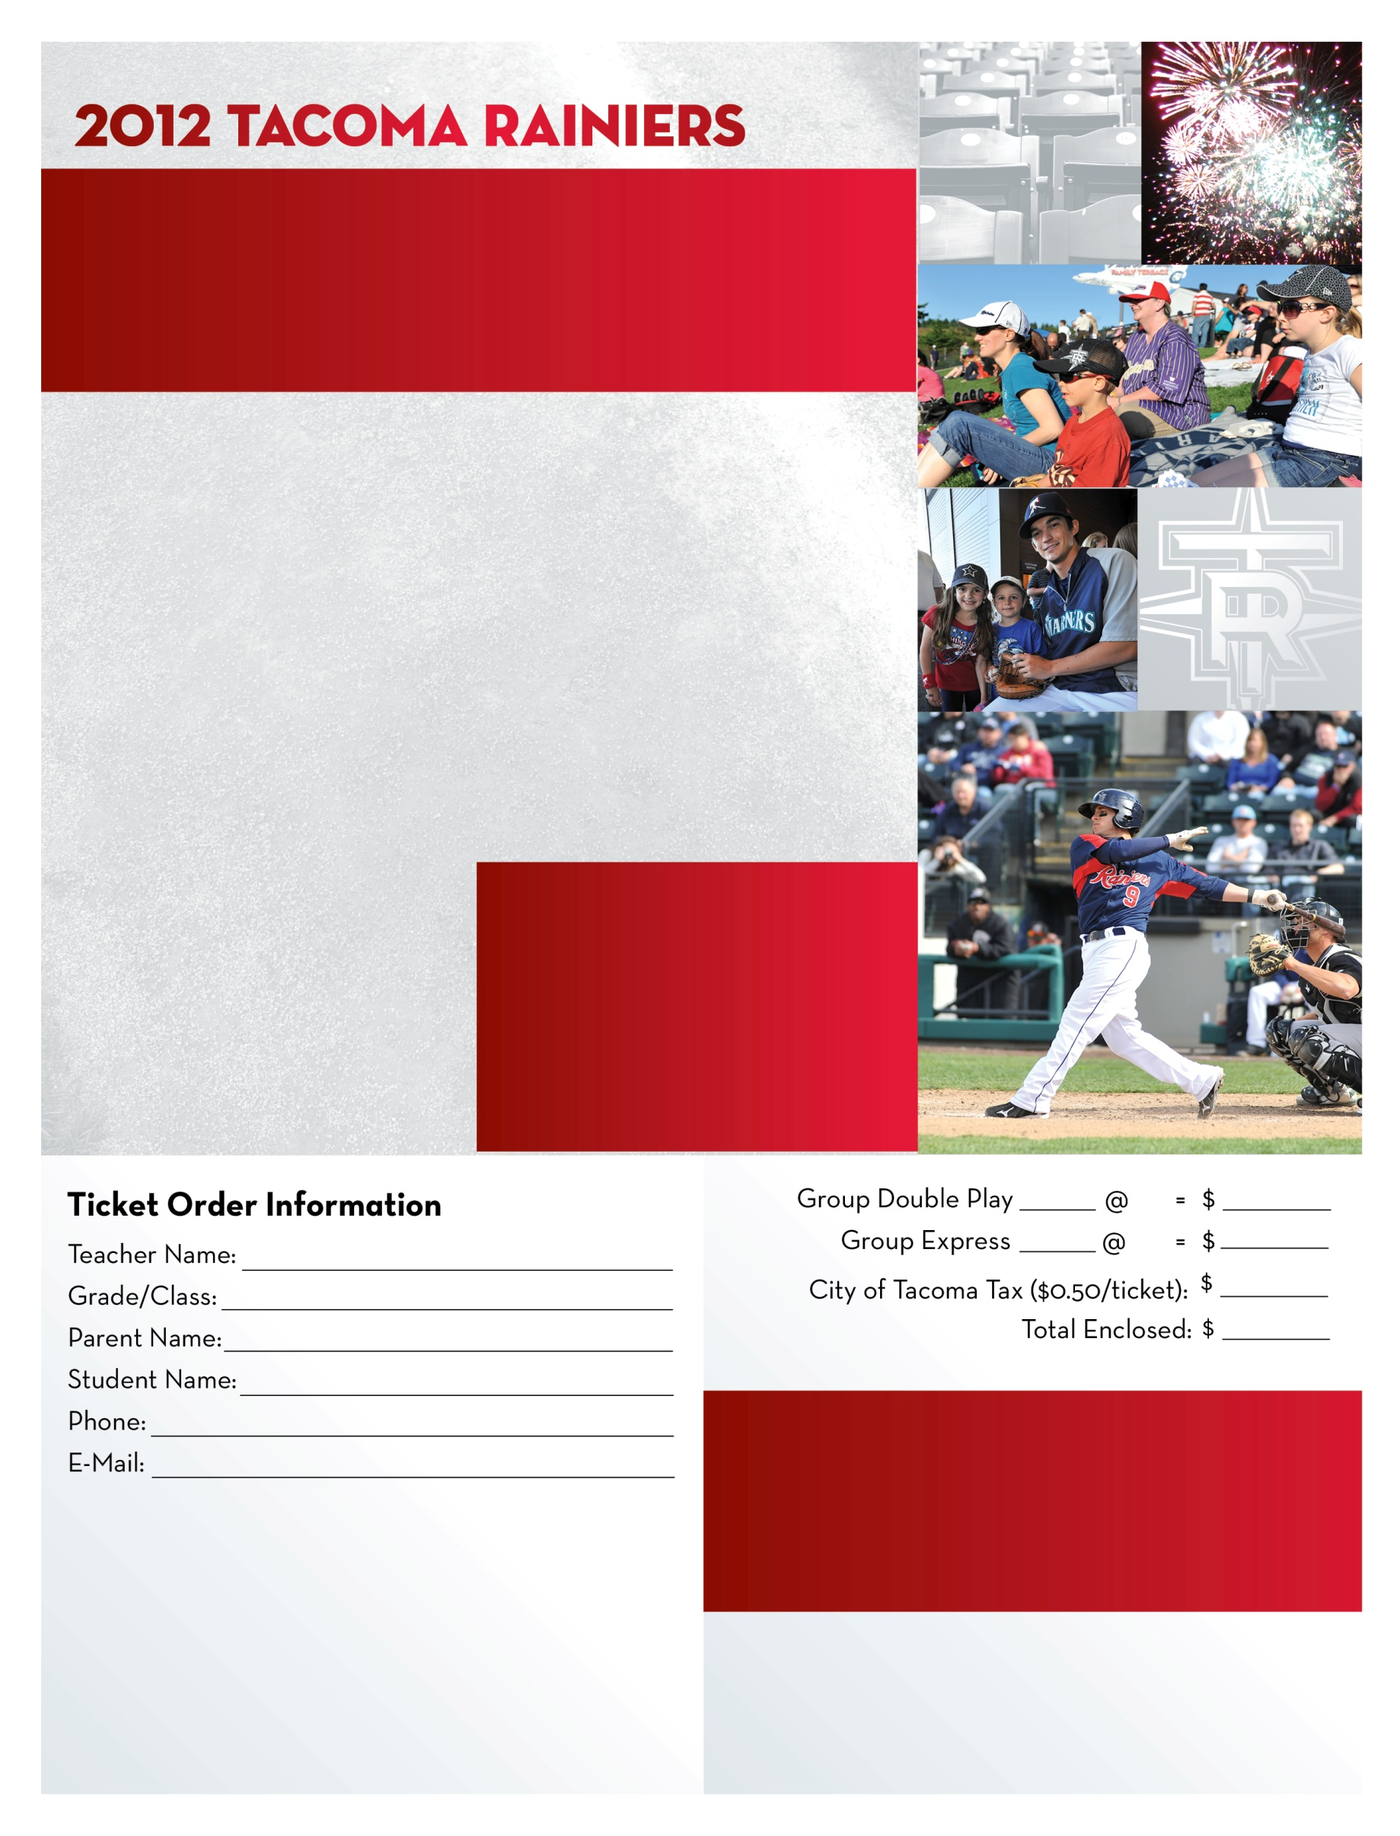

**Please make all checks out to the Tacoma PTA and return the order forms to a representative as soon as possible.**

**Questions?**

**Contact Kellie Bennett of the Tacoma PTA Council:**

**253-439-9680**

**kellielb@hotmail.com**

Groups that order together will be seated together. Orders placed by May 18, 2012 will have tickets mailed to them - all others will be left at Will Call the day of the event. After an order is placed a confirmation email with event details will be sent to the group coordinator.

PLEASE INCLUDE EMAIL ADDRESS ON ORDER FORM.

$16

$10

**Don’t forget! Place your order by May 18th and you will be entered to win a VIP package!**

**Choose the package that fits your family best:**

**Group Double Play: $16.00/person**

**Game Ticket-Reserved Seats**

**Dinner (Hot Dog, Chips, Soda)**

**Limited Edition Tacoma Rainiers Hat**

**Group Express: $10.00/person**

**Game Ticket-Reserved Seats**

**Dinner (Hot Dog, Chips, Soda)**

**Don’t forget about these great details too…**

**-Pre-game player autographs on the concourse**

**-Post-game fireworks show**

**-In-game group recognition on**

**the HD video board**

**-Your school will be featured**

**during the 7th Inning Stretch**

**-$5 Parking**

**Tacoma Council PTA Night with the Rainiers**

**Friday, June 8th, 2012 @ 7:00pm**

**Tacoma Rainiers vs. Salt Lake City Bees**